Warning – Advancetrac Ask on Stuck Turn TCS Off – CGEA1.3

Functional Description

This STSS supports ESC function where the ESC senses the vehicle is stuck and commands a text warning to be displayed with which the customer may use to turn off Traction Control directly and not have to go through the settings menu. This function is only approved for setting menu (soft button) applications. If it is in the future proposed to use this function for hard button applications the feature owner must get approval to do so through DI Change Control and the function within this STSS will have to be updated. This STSS IS NOT COMPATIBLE WITH HARD BUTTON ESC APPLICATIONS.

This function is intended to be compatible with the Advancetrac Control Function section and will change the settings screen indication in Advancetrac Control Function section to reflect the state of the TCS (on or off).

Interfaces

Interface Context Diagram (I/O Block Diagram)
Figure 1 Ask on Stuck Warning Context Diagram
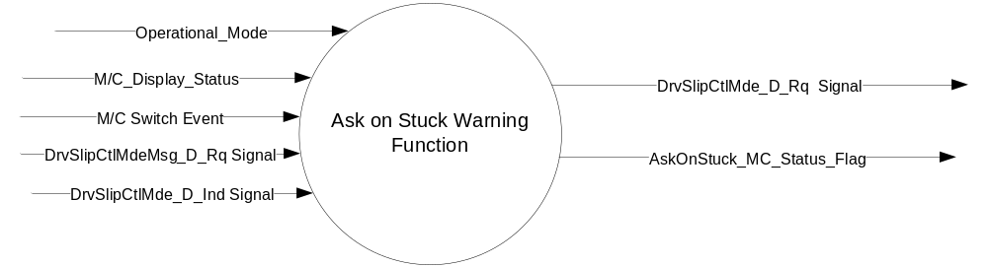

Inputs

- INTERNAL:
- Operational_Mode
- M/C Switch Event
- M/C_Display_Status
- MUX message on the CAN Bus

- DrvSlipCtlMdeMsg_D_Rq Signal
Signal Name | Size  (bits) | Detail | Units | Res. | Offset | State Encoded | Min. | Max.
DrvSlipCtlMdeMsg_D_Rq | 2 |  | SED | 1 | 0 |  | 0  (0x0) | 31 (0x1F)
DrvSlipCtlMdeMsg_D_Rq |  | No Message |  |  |  | 0x0
DrvSlipCtlMdeMsg_D_Rq |  | Message_1 |  |  |  | 0x1
DrvSlipCtlMdeMsg_D_Rq |  | Message_2 |  |  |  | 0x2
DrvSlipCtlMdeMsg_D_Rq |  | Message_3 |  |  |  | 0x3
DrvSlipCtlMdeMsg_D_Rq |  | Message_4 |  |  |  | 0x4
DrvSlipCtlMdeMsg_D_Rq |  | Message_5 |  |  |  | 0x5
DrvSlipCtlMdeMsg_D_Rq |  | Message_6 |  |  |  | 0x6
DrvSlipCtlMdeMsg_D_Rq |  | Message_7 |  |  |  | 0x7
DrvSlipCtlMdeMsg_D_Rq |  | Message_8 |  |  |  | 0x8
DrvSlipCtlMdeMsg_D_Rq |  | Message_9 |  |  |  | 0x9
DrvSlipCtlMdeMsg_D_Rq |  | Message_10 |  |  |  | 0xA
DrvSlipCtlMdeMsg_D_Rq |  | Message_11 |  |  |  | 0xB
DrvSlipCtlMdeMsg_D_Rq |  | Message_12 |  |  |  | 0xC
DrvSlipCtlMdeMsg_D_Rq |  | Message_13 – Message_30 |  |  |  | 0xD – 0x1E
DrvSlipCtlMdeMsg_D_Rq |  | Message_31 |  |  |  | 0x1F

- DrvSlipCtlMde_D_Ind Signal
Signal Name | Size  (bits) | Detail | Units | Res. | Offset | State  Encoded | Min | Max
DrvSlipCtlMde_D_Ind | 5 |  | SED | 1 | 0 |  | 0 (0x0) | 3 (0x3)
 |  | Default_Mode |  |  |  | 0x0
 |  | App_Specific_Off_Mode1 |  |  |  | 0x1
 |  | App_Specific_Off_Mode2 |  |  |  | 0x2
 |  | App_Specific_Off_Mode3 |  |  |  | 0x3

Outputs
- AskOnStuck_MC_Status_Flag
- MUX message on the CAN Bus

- DrvSlipCtlMde_D_Rq Signal
Signal Name | Size  (bits) | Detail | Units | Res. | Offset | State  Encoded | Min | Max
DrvSlipCtlMde_D_Rq | 2 |  | SED | 1 | 0 |  | 0 (0x0) | 3 (0x3)
 |  | Default_Mode |  |  |  | 0x0
 |  | App_Specific_Off_Mode_1 |  |  |  | 0x1
 |  | App_Specific_Off_Mode_2 |  |  |  | 0x2
 |  | App_Specific_Off_Mode_3 |  |  |  | 0x3

Function/Performance

Operational Modes

Mode | Differentiating Vehicle Conditions
Sleep Mode | Ask on Stuck Warning Function Text Messages = Disabled
Limited Mode | Ask on Stuck Warning Function Text Messages = Disabled
Normal Mode | Ask on Stuck Warning Function Text Messages = Enabled / Disabled
Crank Mode | Ask on Stuck Warning Function Text Messages Enabled / Disabled

Voltage Levels

Refer to the Cluster Features table located in the Operational Modes and Voltage Range Strategies Section in this SPSS.

Human-Machine Interface

Visual

Indicator Graphics / Display Format
Example Graphics W3570:


Indicator Color Coordinates

Reference section COLOR & ILLUMINATION REQUIREMENTS (GRAPHICS)

Indicator Characteristics

Refer to Message Center X Display_Y Button Interface Section, where X and Y are appropriate values in this document.

Audio

Message Center Informational Chime

Switch Control Logic

The definition of Ok button press and as to whether or not Yes or No is highlighted is defined in the appropriate HMI flow or Message Center STSS.

System Accuracy

Within a 100msec of receiving a message that results in a change of state the cluster will update the display to the proper status.

Operation: Performance and Functional

Subsystem Algorithm Flowchart / State Diagram

Figure 4: Ask On Exit Warning Settings Function Flowchart

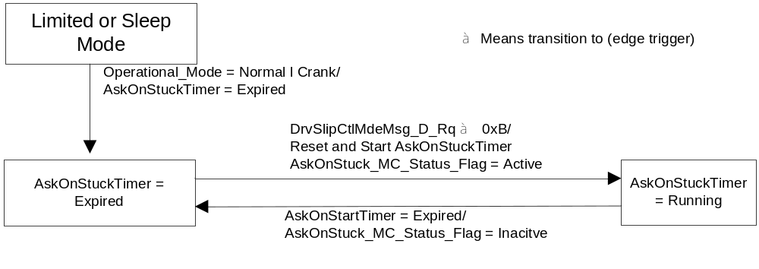

Figure 5 Ask On Stuck Warning and TCS Disable Function

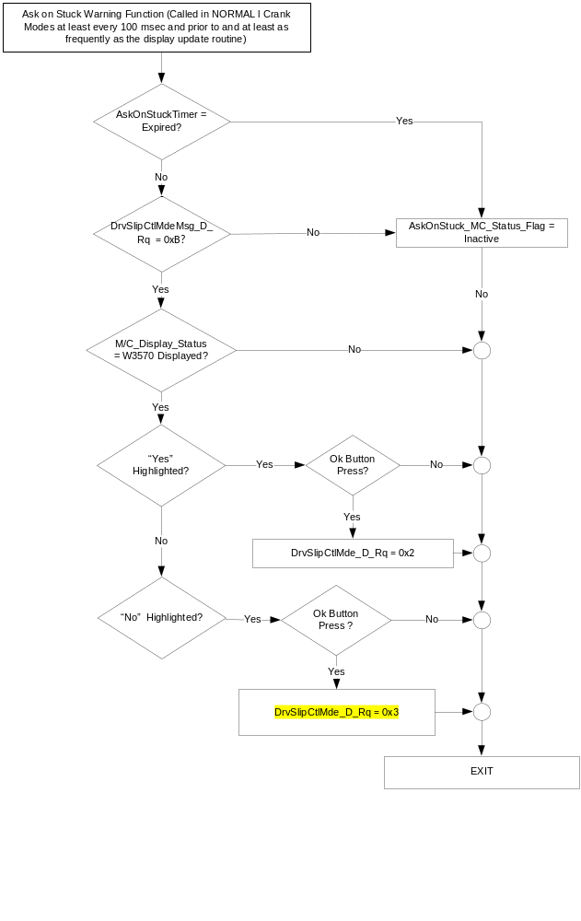
NOTE: The definition of Ok button press and as to whether or not Yes or No is highlighted is defined in the appropriate HMI flow or Message Center STSS.

Figure 6 DrvSlipCtlMde_D_Rq reset to 0x0 function

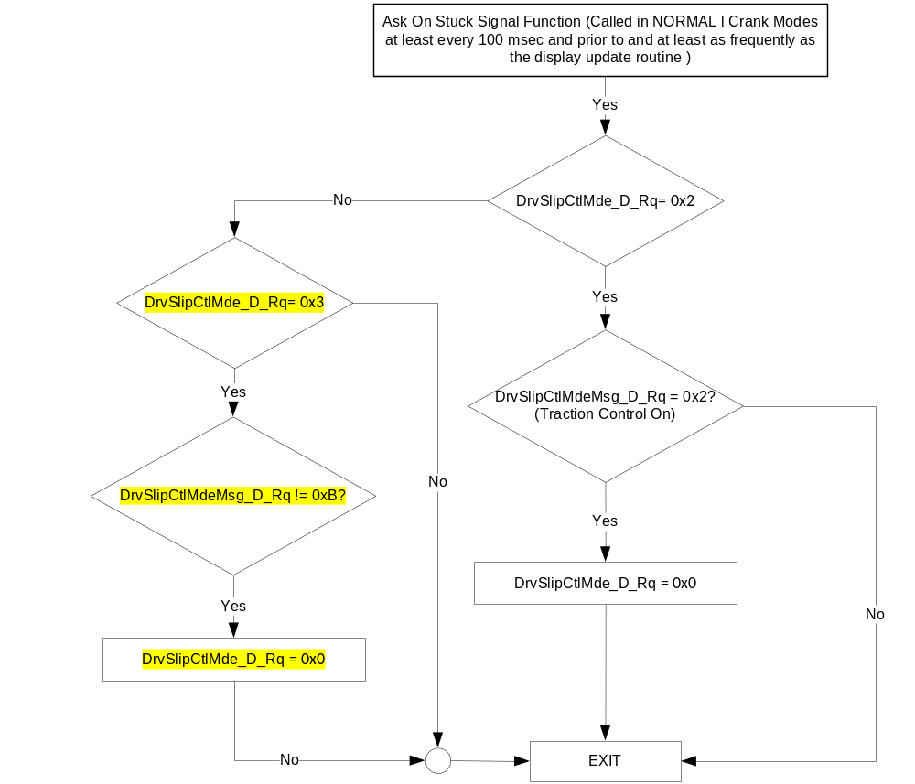

Operation Description (supports algorithm flowchart /state diagram)
- W3570 shall default to the “Yes” choice being highlighted upon display. This will allow the operator to turn off TCS with a single “Ok” button press without having to navigate.
- This function will impact TCS On/Off status in the AdvanceTrac Control Function settings screen. The Advancetrac Control Function settings screen will indicate whether TCS is On or Off and need not be modified for this function. Once TCS is turned off using W3570 the ESC system will automatically turn TCS back on upon the vehicle no longer being stuck. Also, after the operator has turned TCS off via W3570 they are able to turn TCS back on manually using the settings screen.

- State Matrix for Traction Control Off, Traction Control On, and for Ask on Stuck
Operational_Mode | DrvSlipCtlMdeMsg  _D_Rq Signal | Traction_OFF_MC  _Status_Flag | Traction_ON  _MC_Status  _Flag
Normal or Crank | Message_1 (0x1) | Active | Inactive
Normal or Crank | Message_2 (0x2) | Inactive | Active
All Other Cases |  | Inactive

- MC_Status_Flag to W# Mapping
Traction_OFF  _MC_Status_Flag | Traction_ON_MC  _Status_Flag | AskOnStuck  _MC_Status_Flag | MC Message ID | Associated Chime Status Flag⁽¹⁾
Active | Inactive | Inactive | W901 | None
Inactive | Active | Inactive | W906 | None
Inactive | Inactive | Active | W3570 | Message_Center_Informational_Chime_Status_Flag
- Set to active while associated MC_Status_Flag is Active otherwise Inactive.

Function Safety Classification (EMC)

Class B

Memory Storage

Parameter Name | Description | Value at  Battery  Connect | Value at  Module  Wake-up | Value upon  Entering Run/  Start/Accessory from Off
AskOnStuck_MC_Status_Flag | Internal variable used to determine whether to display warning message. | Inactive | Inactive | Inactive
DrvSlipCtlMde_D_Ind Signal | Input signal indicating whether TCS has been turned off or is On | (0x0) | (0x0) | (0x0)
DrvSlipCtlMdeMsg_D_Rq Signal | Input signal used to display certain warning messages. | (0x0) | (0x0) | (0x0)
DrvSlipCtlMde_D_Rq Signal | Output signal to reflect requested guard state of the Perimeter Alarm | (0x0) | (0x0) | (0x0)
M/C_Display_Status | State Indicator to identify which text is currently being displayed on Message Center display. See * | See * below | See * below | See * below
M/C Switch Event | Event that is indicated as per the switch interface for the Message Center. See * | See * below | See * below | See * below
Operational_Mode | 4 state indicator for cluster operational mode | Limited | Limited | Limited, Normal or Crank
* Refer to Message Center X Display_Y Button Interface Section, where X and Y are appropriate values in this
document.

Parameter Name | Description | Range | Units | Resolution | Init Value
AskOnStuck_Timer | Timer used to allow W3570 to display. | 0 – 30 | Seconds | 1 | 30

Reconfigurable Telltale

Not Applicable

Prove Out

Not applicable

Message Center Msg

W3570.

Error Handling

Missing Message Strategy

No DTCs are associated with this section. All signals are used in other sections and DTCs are
specified in those sections.

Diagnostics

Self Test

None

Engineering Test Mode

Reference section “Dealer / Engineering Test Mode (ETM)”

Part II Performance

Supported Diagnostic Trouble Codes (DTCs)
DTC | Description
None

DID DExx: None
Block  Num | Block Description | Byte(s) | Bits | State: Description | "0" | "1" | Default | Comments/Information
PACKETED BLOCKS
 | *Byte and bit location to be identified in Part II Specification for this cluster

Reference Specification – Attached below is agreed systems level function for Ask On Stuck feature.



Revision History
SPSS Module Revision History
Revision Level | Name | Change Description | Date
1.0 | J. Blatchford | Initial Release | 10/28/16
2.0 | J. Blatchford | This update adds function so that IPC sends DrvSlipCtlMde_D_Rq = 0x3 if the operator selects to not turn TCS Off from the Ask On Stuck (W3570) warning. ABS module will use this information to not redisplay W3570 for that key cycle. This update also adds agreed upon systems function as pdf file in section 1.6 and changes maximum display of the warning to 30s. Changes highlighted in yellow.  - Figure 5: Updated function.  - Figure 6: Updated function.  - 1.6: Added PDF file with agreed upon systems function per  02Feb2017 meeting between Alex James, Scott Watkins, and  Jim Blatchford.  - 1.3.5.4: Changed AskOnStuck_Timer Init value to 30 so  warning will display for a maximum of 30s. | 2/14/2017

